# Tutorial

## Activity 1: Writing copy for your first web page

In the lab this week, you will be forking and cloning a starting repo which contains very basic HTML5 web page templates, one which you will modify with some information about yourself.

Some things to think about:

* How do you use the internet?
* What websites do you visit? (NB: "family friendly" !)
* Have you any programming or web design experience?
* Do you see yourself as a programmer or designer, or both?
* What has brought you to this course at RMIT?
* What are you hoping to get out of the course?
* What are your interests or hobbies?

Work with one or two friends to flesh out your copy.

This activity is to get to know your classmates and yourself a little better. By the end of this exercise you should have some idea of what to put in your personal webpage.

For administrative reasons, there will be a few other fields to fill in (name, student number, a personal photo). This will help the entire web programming team get to know you better and more importantly know how to pitch answers to your questions.

## 

## 

## Activity 2: Examine the Elements of a Webpage

Have a look at the following webpage: <http://www.w3schools.com/html/html_intro.asp>. The top and bottom of the page is shown with a red bar separating the two sections. *If you have a laptop please have a look at the live version*.

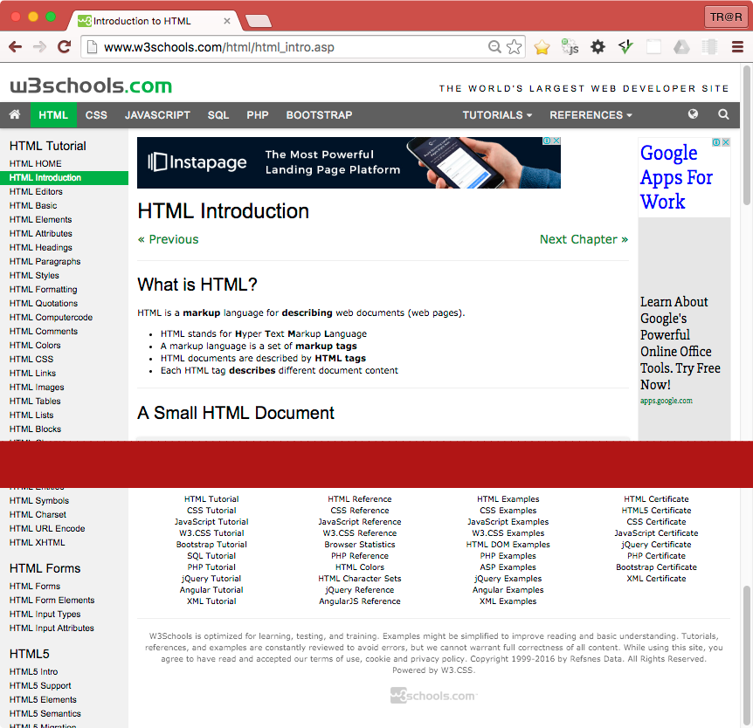

* On the webpage above, identify the following web elements:
  + Headings (eg <h1>...</h1>, <h2>...</h2>, … , <h6>...</h6>),
  + Paragraphs (<p></p>),
  + Anchors or Hyperlinks (<a href="...">...</a>),
  + Images (<img src="..." alt="..."/>) and other multimedia.
* Identify styling such as **bold** and **italic** text. We will cover shading and colouring next week.
* What is the difference between an **unordered list** (<ul>) and **list items** (<li>). Can you see examples of each on the webpage above?
  + List items (<li>) are placed inside unordered list (<ul>)
* Does this website use modern HTML5 Contextual Elements? (eg <header>, <nav>, <main>, <footer>, <aside>). Identify which areas should be grouped into these elements.
  + No it doesn’t use modern HTML5 contextual elements
  + The first <div> in the <body> can be a <header>
  + The fourth and fifth <div> can be a <nav>
  + The sixth <div> can be a <main>
  + The <div id=”footer”> can be a <footer>
  + The “Tip” div can be a <aside>
* How many navigation elements are there? If more than one, why are there more than one?
  + There are at least 2 navigation elements: One on the top and one of the left

## 

## 

## 

## Activity 3: Evolution of the HTML standard

What page elements were present in the very first versions of HTML? What form did the first web documents take?

* Some page elements in HTML version 1: <HEADER>, <BODY>, <NEXTID>, <H1>-<H6>, <DL>, <DT>, <A>, <P>, <TITLE>, <ISINDEX>, <PLAINTEXT>, <LISTING>, <ADDRESS>, <HP1>, <UL>, <LI>
* First web documents take the form of

HTML3 and HTML4 standards were developed at a time that was seen as being very chaotic. Name some reasons for why this was and state what new elements we saw introduced at this time.

* During this time, there are 2 main web browsers, Netscape Navigator and Microsoft Internet Explorer. It was very frustrating as a web developer as code developed for one browser would not work in the other, browser developers didn’t adhere to W3C rules. Later, as Microsoft made IE free as part of Windows 95+, Netscape is pushed out of the market and web developers mainly develop for IE.
* HTML3 was developed by the HTML Working Group, a branch of the World Wide Web Consortium, in 1997. It removed math formulas completely, these were later standardized in MathML. HTML3 added some good tags such as <img> and <table>, which survived till this day and later become part of the standard, while tags such as <blink> and <marquee> are not recommended and become non-standard. Various visual markup tags such as <font>, <style>, <color>, <border> and <alignment> were created. Content and styling are mixed together in a HTML document.
* In 1999, HTML4 modernized HTML3.2 and was adopted widely. Previous styling and visual tags such as <center>, <font>, <strike>, <u>, <align>, <color> were removed. Styling are now used in Cascading Style Sheets as much as possible. Tags such as <b> and <i> are renamed to <strong> and <em> to be more verbose and meaningful.

The XHTML standard is described as being very strict, quite unlike HTML3 and 4. What rules did XHTML impose on developers? Think in terms of:

* Tags: closing and nesting them in correct sequence.
  + All tags must be closed, even on empty tags, e.g. <img … />, <br />
  + Tags must be nested correctly in sequence, e.g. <p><em>example<em/><p/>
* Use of uppercase and lowercase characters.
  + All tags now must be lowercase, e.g. <BODY> into <body>, <A> into <a>
* Separation of style and content
  + Most styling and visual tags are now deprecated
  + Styling should be use as much as possible in a separate Cascading Style Sheet

How did these changes allow XHTML documents to be more accessible across a wider range of devices: eg PC's, early WAP enabled mobile phones, screen readers for the visually impaired etc.

* The changes and rules and changes in XHTML allow it to be more easily accessible for other wireless devices at the time. This is possible through a methodology called XHTML modularization, which can produce various modules and easily plugged together to create markup languages. This means XHTML can be repurpose for different devices. XHTML Basic, a subset of XHTML, is created by using XHTML modularization and suitable for mobile phones, pagers, etc. It can be rendered differently depends on which device is using it, doesn’t need to have a version for each device.

HTML5 introduced many new elements and attributes. Think in terms of:

* Simpler doctype declaration.
  + The new HTML5 standard brings a much simpler doctype declaration

<!doctype html>

<html lang="en">

* New tags, including standard multimedia tags (audio/visual).
  + New tags such as <video> and <audio> replace third party plugins such as Quicktime and Flash
* New form inputs, validation of form data using html markup, not code/scripting
  + New form input types and attributes such as email, date, color, range, etc. made web development easier as it is packed inside a single HTML document without the need of external scripts
* Semantic Web elements
  + New semantic tags are introduced, making the structure more readable and verbose, also help search engines optimize page rankings

Discuss the benefits and improvements contained in the HTML5 standard.

* New changes made HTML5 more accessible for new web developers as the learning curve is now less steep
* A HTML5 code/document is now more readable and structured with the use of new semantic tags

Finally, HTML5 has brought back many (but not all) of HTML4's more relaxed coding rules. What are they and why are the strict XML syntax rules of XHTML no longer needed today?

* HTML5 rules are more sensible, relaxed and not overtly strict, unlike XHTML
  + Empty tags don’t need closing slash, e.g. <br>
  + Values with no spaces don’t need quotes, e.g. value=1
  + Attributes can be minimized, e.g. async, active
  + Stylistic tags such as <b> and <i> are brought back with more specific meanings
* XHTML 2.0 weren’t backwards compatible with any previous XHTML versions meaning developers had to do a full rewrite to convert their XHTML 1.x site to XHTML 2.0 compatible. As time progressed, HTML5 grew away from W3C and developed through a group of browser manufacturers. XHTML 2.0 are considered to be too document-centric and unsuitable for the modern uses of online sites.
* Furthermore, HTML5 has an XML serialization known as XHTML5 which is even more backwards compatible with HTML4 and XHTML 1.x than XHTML 2.0. This brings an end to the need of XHTML 2.0,

## 

## 